Exp.No:34
34. Morphological operations based on OpenCV using Top hat technique.

Aim:
To perform the Top Hat morphological operation using OpenCV.
Procedure:
- Read the input image.
- Create a structuring element.
- Apply the Top Hat operation.
- Display the original and Top Hat images.
- Save the output.
Program:
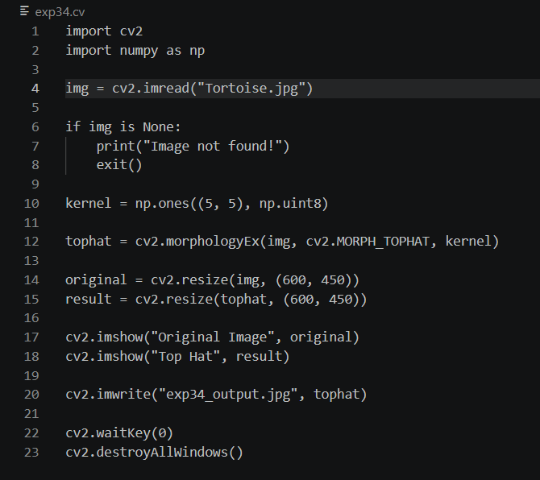

Input:

Output:
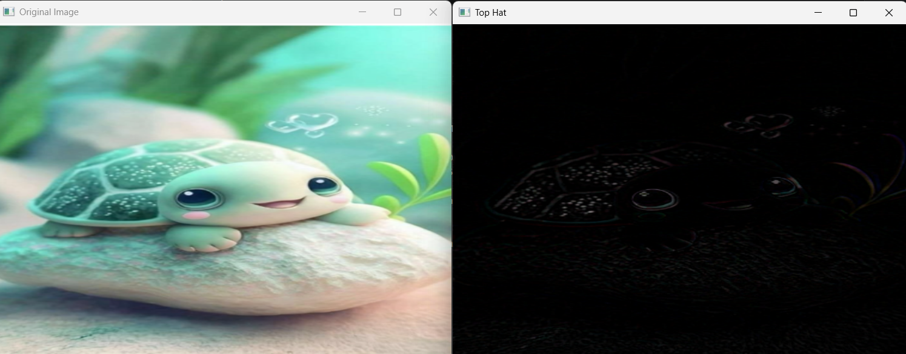

Result:
The Top Hat morphological operation was successfully performed.

